Exp. No: 2 Determination and plotting of Electric field and Electric flux density in sphere full of charges with varying radius.
Aim:
To write program for electric field and electric flux density in sphere using SCILAB.
Software required:
•SCILAB version 6.0.1
Program :
clc;
clear;
q = 5*10^-6;
r = 3*10^-3;
epsilon = 8.854*10^-12;
pi = %pi;
E = q/(4*pi*epsilon*r^2);
disp("Electric Field Intensity (E) in V/m =");
disp(E);
D = epsilon * E;
disp("Electric Flux Density (D) in C/m^2 =");
disp(D);
x = linspace(0,10,50);
y = E * exp(-0.1*x);
z = D * exp(-0.1*x);
figure();
subplot(2,2,1);
plot2d3(x,y);
xlabel("Distance");
ylabel("Electric Field (V/m)");
title("Electric Field Intensity");
subplot(2,2,2);
plot2d3(x,z);
xlabel("Distance");
ylabel("Electric Flux Density (C/m^2)");
title("Electric Flux Density");
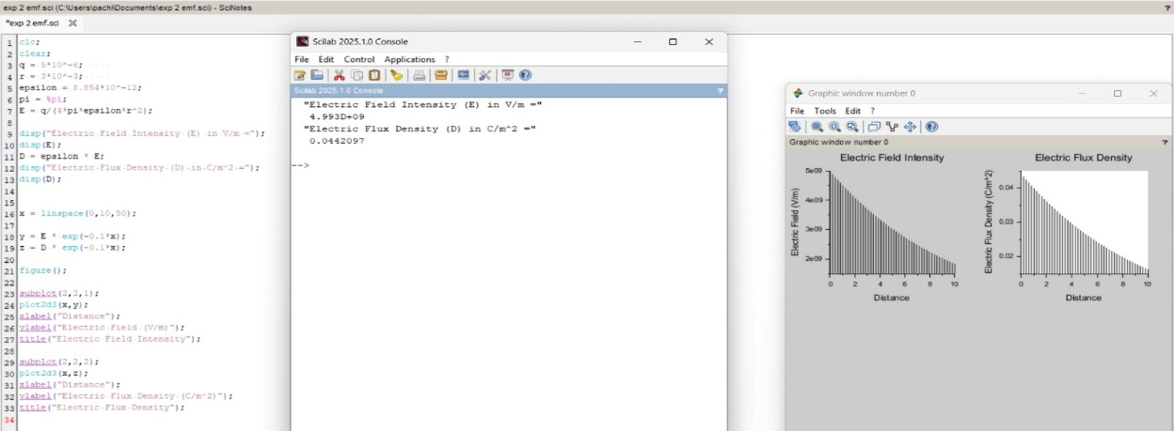
OUTPUT :
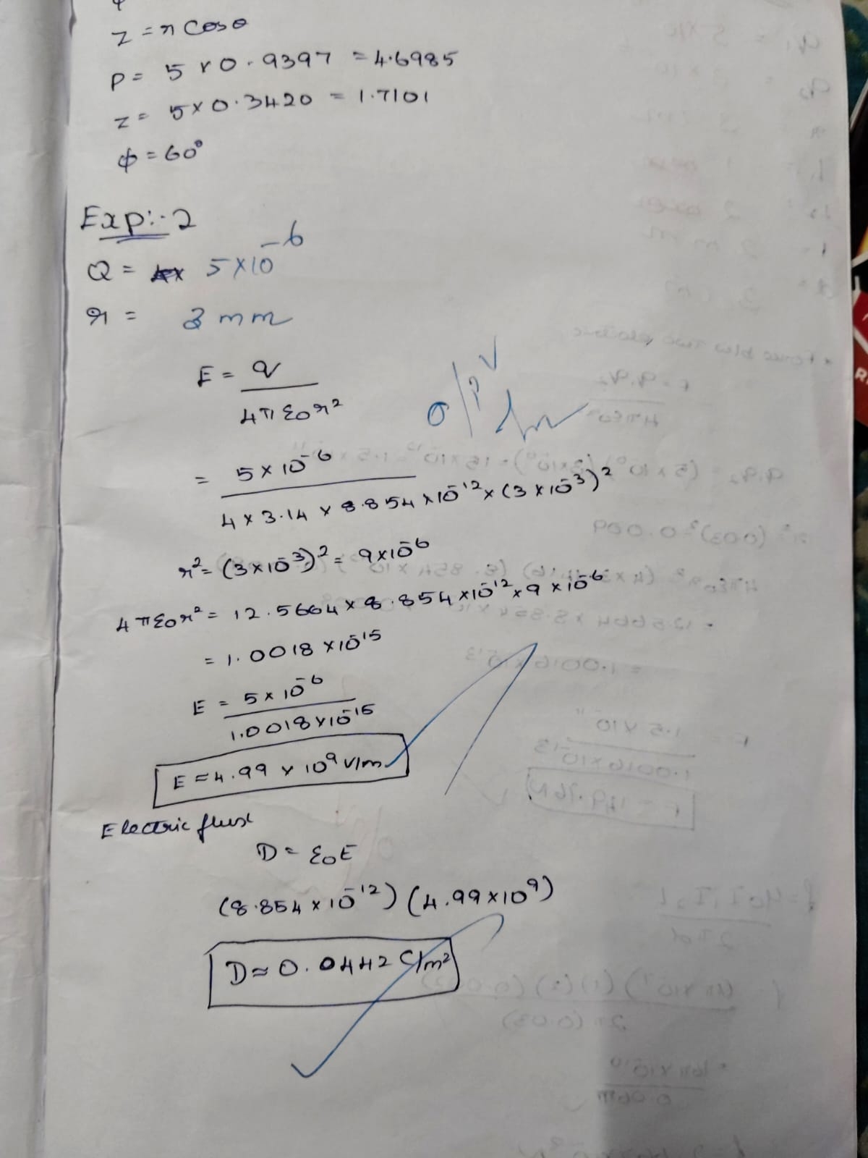

Case 1: Derive and plot the electric field (E) and electric flux density (D) inside a uniformly charged sphere with charge density ρ0. What are the values of E and D at the center and at the surface of the sphere?
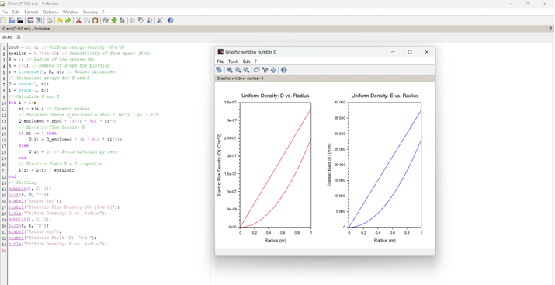

Case 2: For a sphere with a linearly increasing charge density ρv=ρ0r.derive the expressions for the electric field (E) and electric flux density (D). Plot their variations inside the sphere and analyze the trends.
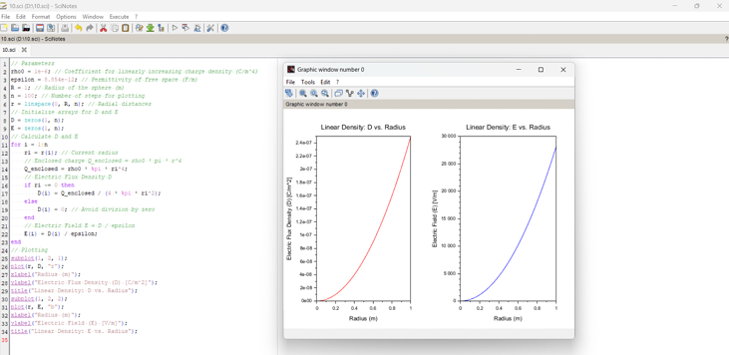

Case 3: A sphere of radius R=2 m has a uniform charge density ρ=3×10^−6 C/m^3\ 1. Calculate and plot the electric flux density D(r) and electric field E(r) as a function of radial distance r, ranging from 0 to 4 meters. 2. Discuss the behaviour of the electric field inside and outside the sphere.
